Circuit Analysis (Lab # 6)
Experiment 6: VERIFICATION OF KIRCHHOFFS LAWS

Circuit - KCL

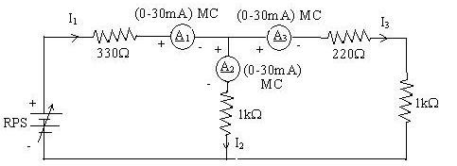

Calculations:
Step 1: Node Relation
At the junction:
$$I_{1}=I_{2}+I_{3}$$
Step 2: Equivalent Resistance
The parallel branch is:
$$R_{eq}=\frac{220⋅1000}{220+1000}≈180.3 Ω$$
So total resistance:
$$R_{total}=330+R_{eq}≈330+180.3=510.3 Ω$$
Step 3: Current from Source
$$I_{1}=\frac{E}{R_{total}}$$
- For $E=5V$:
$$I_{1}=\frac{5}{510.3}≈0.0098 A=9.8 mA$$
- For $E=15V$:
$$I_{1}=\frac{15}{510.3}≈0.0294 A=29.4 mA$$
- For $E=25V$:
$$I_{1}=\frac{25}{510.3}≈0.0490 A=49.0 mA$$
Step 4: Voltage Across Parallel Branch
$$V_{branch}=I_{1}⋅R_{eq}$$
- At 5 V:
$$V_{branch}=9.8×{10}^{-3}⋅180.3≈1.77 V$$
- At 15 V:
$$V_{branch}=29.4×{10}^{-3}⋅180.3≈5.31 V$$
- At 25 V:
$$V_{branch}=49.0×{10}^{-3}⋅180.3≈8.85 V$$

Step 5: Currents in Each Branch
$$I_{2}=\frac{V_{branch}}{220},I_{3}=\frac{V_{branch}}{1000}$$
- At 5 V supply
$$I_{2}=\frac{1.77}{220}≈8.05 mA$$
$$I_{3}=\frac{1.77}{1000}≈1.77 mA$$
Check:
$I_{2}+I_{3}≈9.82 mA≈I_{1}$
- At 15 V supply
$$I_{2}=\frac{5.31}{220}≈24.1 mA$$
$$I_{3}=\frac{5.31}{1000}≈5.31 mA$$
Check:
$I_{2}+I_{3}≈29.4 mA≈I_{1}$

- At 25 V supply
$$I_{2}=\frac{8.85}{220}≈40.2 mA$$
$$I_{3}=\frac{8.85}{1000}≈8.85 mA$$
Check:
$I_{2}+I_{3}≈49.0 mA≈I_{1}$

---------------------------------------------------
Circuit - KVL
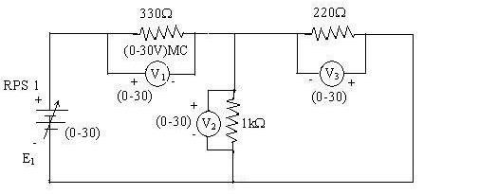

Calculations:
Step 1: Total Resistance
$$R_{total}=330+220+1000=1550 Ω$$
Step 2: Current in the Circuit
$$I=\frac{E_{1}}{R_{total}}$$
- For $E_{1}=5V$:
$$I=\frac{5}{1550}≈0.00323 A=3.23 mA$$
- For $E_{1}=10V$:
$$I=\frac{10}{1550}≈0.00645 A=6.45 mA$$
- For $E_{1}=15V$:
$$I=\frac{15}{1550}≈0.00968 A=9.68 mA$$
Step 3: Voltage Drops Across Each Resistor
$$V=I⋅R$$
- At 5 V supply
$$V_{1}=3.23×330≈1.06 V$$
$$V_{2}=3.23×1000≈3.23 V$$
$$V_{3}=3.23×220≈0.71 V$$
Check:
$V_{1}+V_{2}+V_{3}≈5.0 V$
- At 10 V supply
$$V_{1}=6.45×330≈2.13 V$$
$$V_{2}=6.45×1000≈6.45 V$$
$$V_{3}=6.45×220≈1.42 V$$
Check:
$V_{1}+V_{2}+V_{3}≈10.0 V$
- At 15 V supply
$$V_{1}=9.68×330≈3.19 V$$
$$V_{2}=9.68×1000≈9.68 V$$
$$V_{3}=9.68×220≈2.13 V$$
Check:
$V_{1}+V_{2}+V_{3}≈15.0 V$

-----------------------------------------------------------

